Javascript Exercises

1. Write a JavaScript program to get the current date in UTC format?
2. Write a JavaScript program to display the current day and time?
3. Write a JavaScript program to determine whether a current year is a leap year in the Gregorian calendar?
4. Write a JavaScript program to calculate multiplication and division of two numbers (input from user).

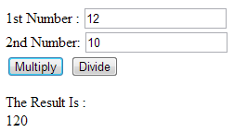

1. Write a JavaScript program to convert temperatures to and from Celsius, Fahrenheit?

Formula C = (5/9) \* (F - 32)

1. Write a JavaScript program to get the current website URL?
2. Write a JavaScript program to get the difference between a given number and 13, if the given number is greater than 13 return double the absolute difference.
3. Write a JavaScript program to compute the sum of the two given integers. If the two values are same, then returns triple their sum
4. Write a JavaScript program to check a given integer is within 100 to 400?
5. Write a JavaScript program check if a given positive number is a multiple of 3 or a multiple of 7.
6. Create a digital clock using javascript, which should display current time.